Hyun Lee

7 June 2022

Foundations in Programming: Python

Assignment 08

<https://github.com/teletubbymilk/Introtopython_module8>

Classes

## Introduction

This week, through the module I learned how to use classes, constructors, destructors, properties, methods, and methods. The assignment today was to read and understand the pseudo code, then to add code to make the application work, whilst including error handling. The script template was created by Randall Root, and I added codes to it.

## Creating Script

This week, I didn’t have to start by writing pseudo codes and guides for my script as it was already written by my professor. So first I started by editing the comments and little details. Then I added constructors so that it will automatically run. I defined a function with attributes and the init method. Then I set the properties for the product name. I did the same thing for product price as product name. (Figure 8)

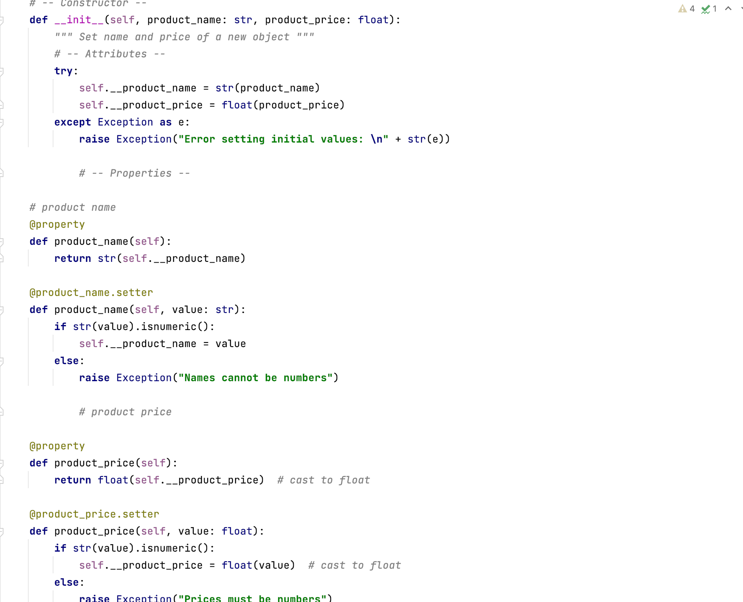

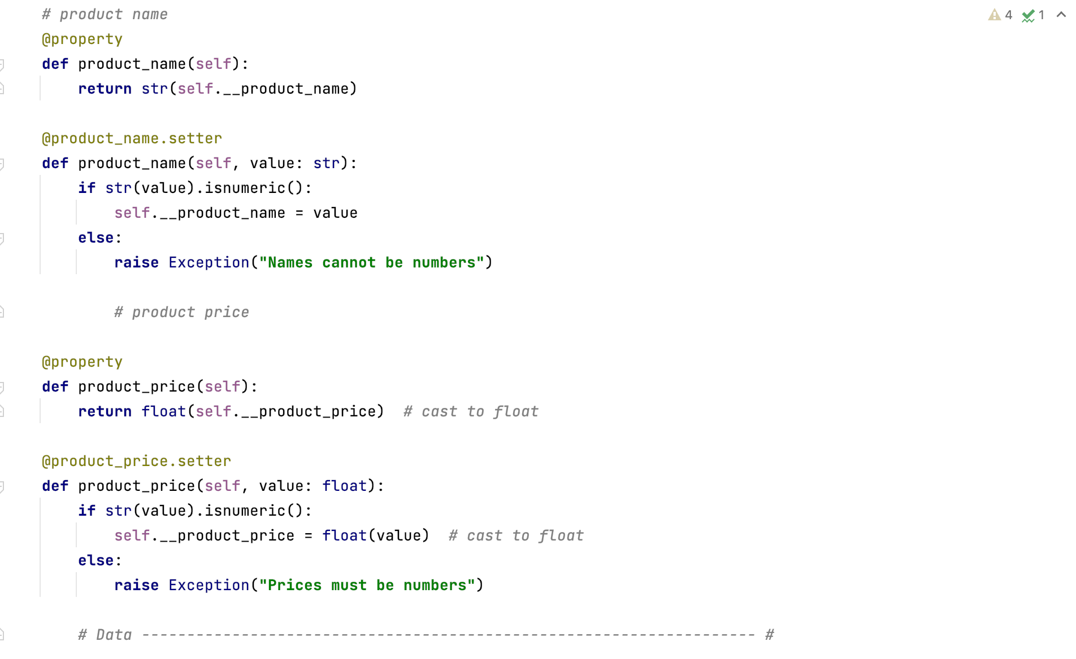

Figure 8: product class

For this fileprocessor class I added code to process data to and from a file. I also included some structured error handling using the try and except function and writing a user friendly message when there’s an error. (Figure 2)

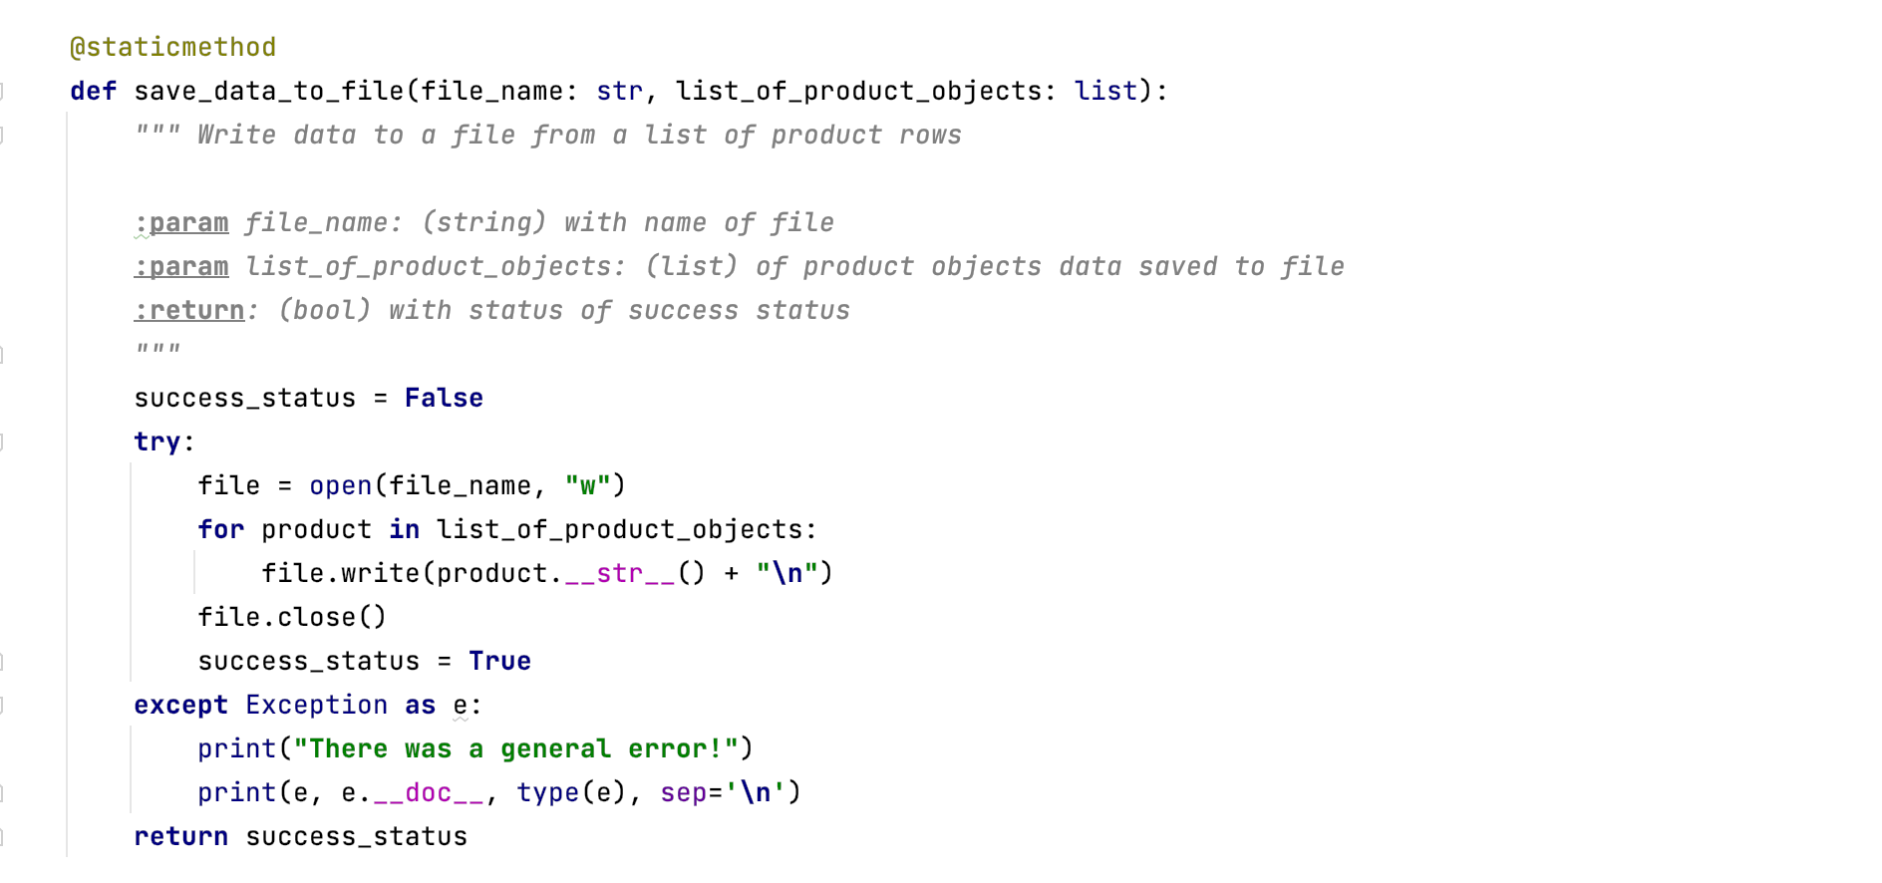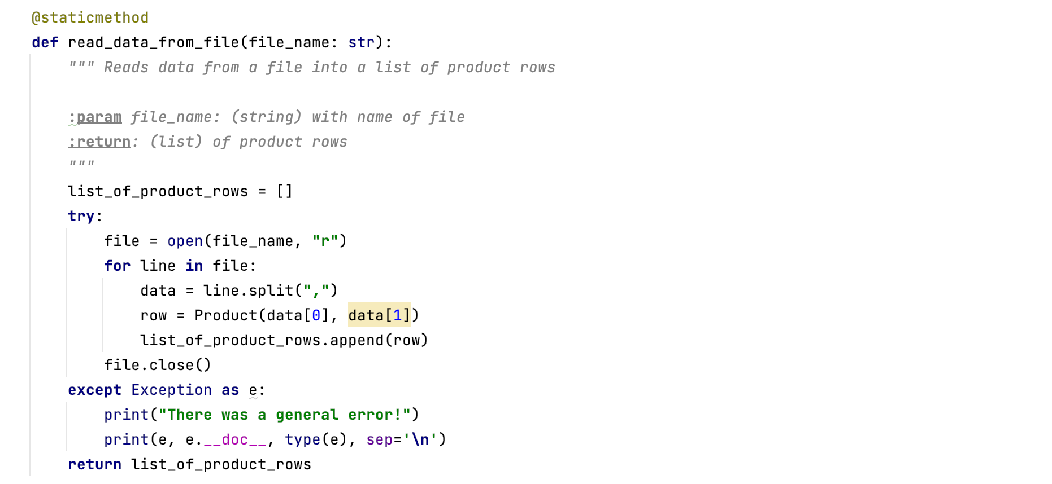

Figure 2: class fileprocessor

For the presentation, hence the input and output, first I added docstring. Then I added codes to show the menu to users. I also wrote code so that it would get user input choice. Additionally, I added codes for the display of current data and to get product data to the user. (Figure 3)

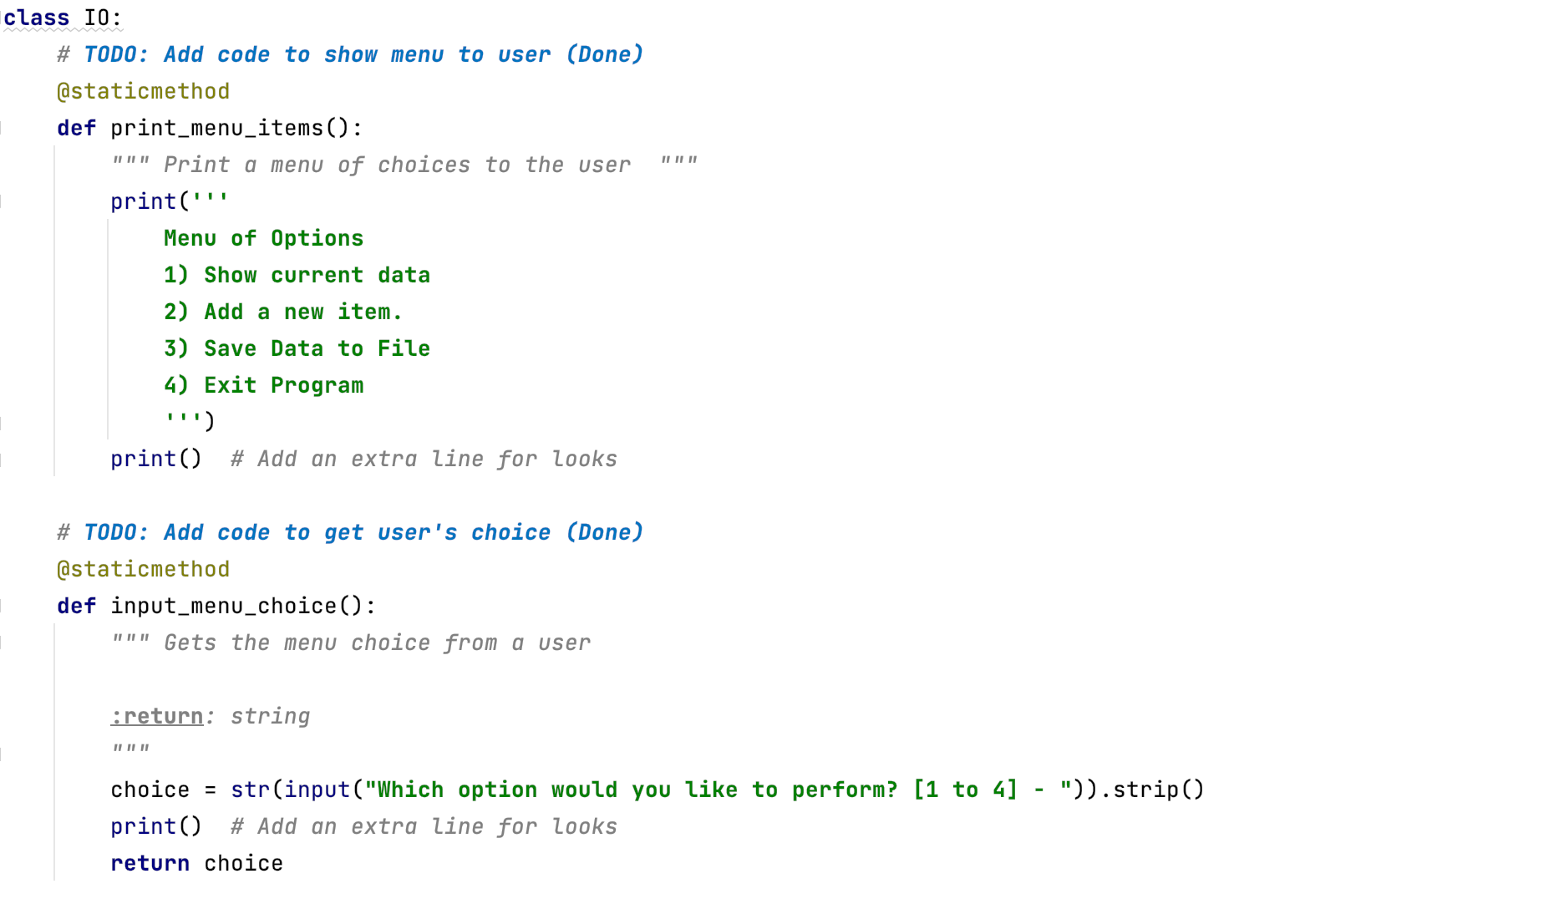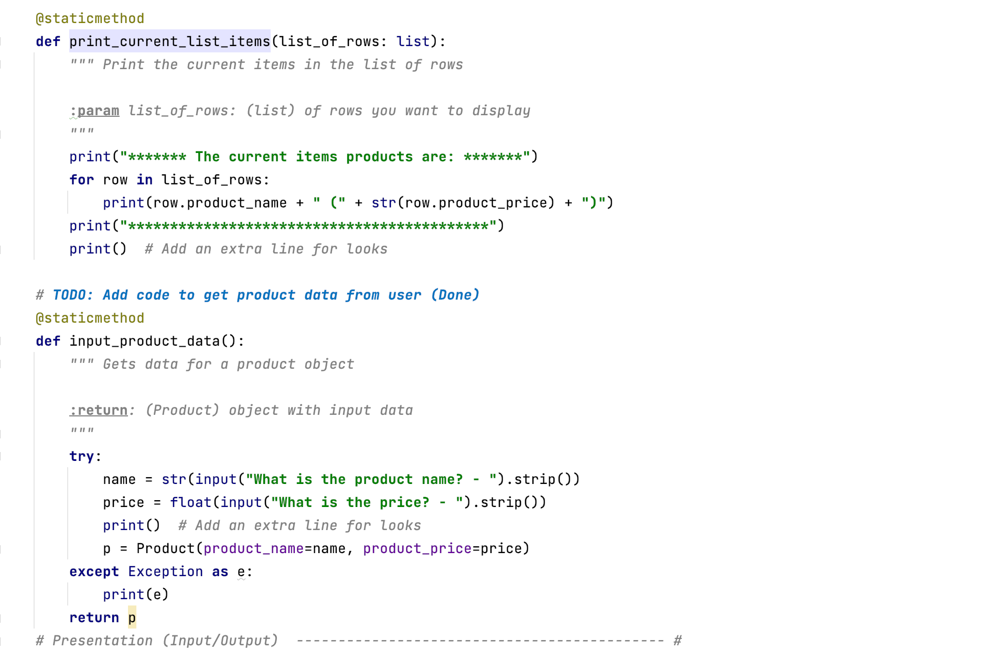

Figure 3: class input and output

For the main script I added codes to load data from file into a list of product objects when script starts, show user a menu of options, and get user's menu option choice (showing user current data, letting user add and save data) (Figure 4)

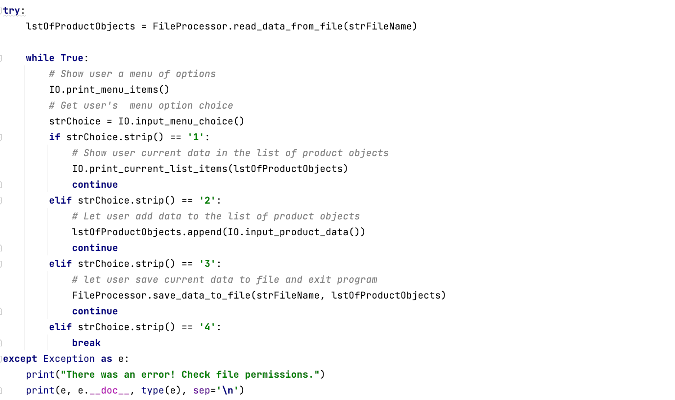

## Running the script

First, I ran the script in PyCharm to check if it is running correctly. (Figure 5)

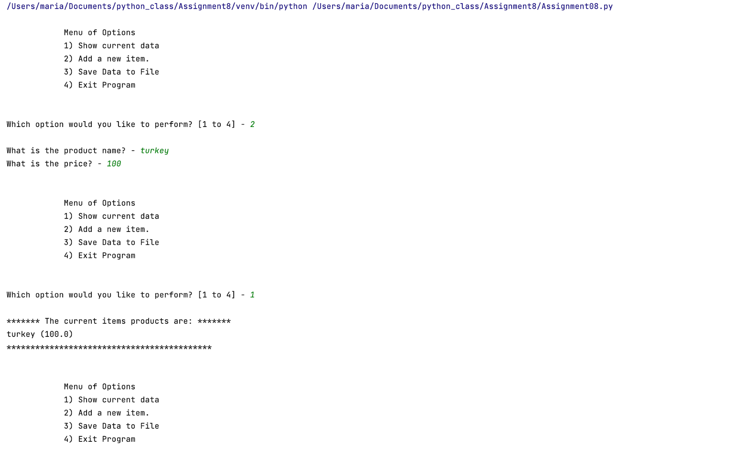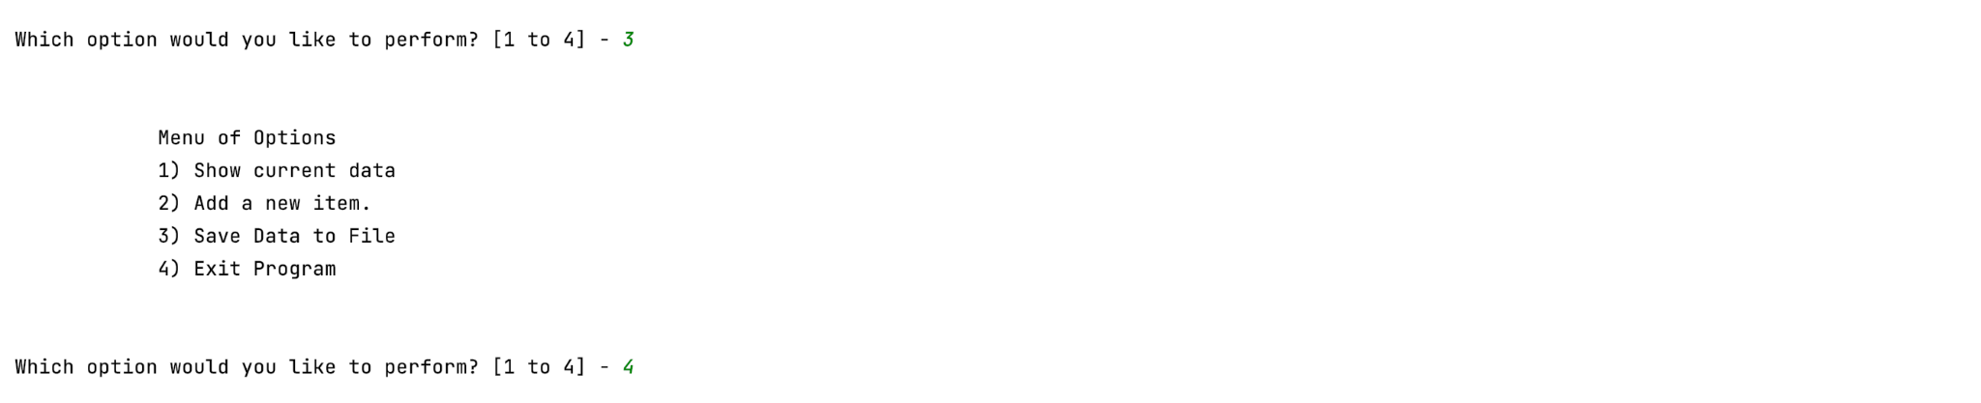

Figure 5: running script on pycharm

I also ran the script in Command Shell/ Terminal to check that it also runs on the computer. To test this script on terminal, I searched for terminal on spotlight search. Then I copied the file path on the terminal and ran it through python. (Figure 6)

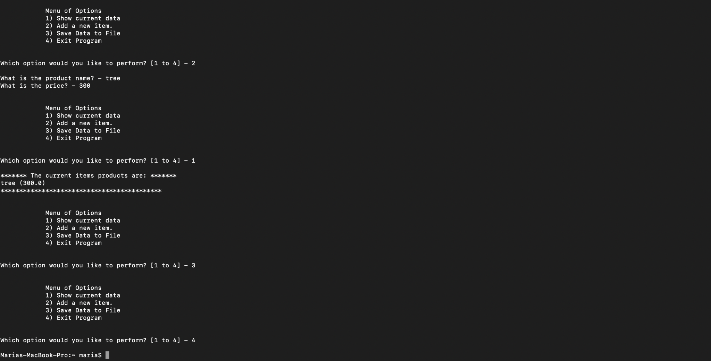

***Figure 8: Running script on terminal***

## Summary

By going through the module course notes and reading the python programming book, I was able to add codes into the pre-written structure to create a programme. This program demonstrates my understanding of classes.